 Final Year Project - UG
School of Computing Science and Engineering (SCOPE)
B.Tech. CSE/CPS/AL AND ML Capstone Project IN HOUSE
Weekly Status Report – Week_04- 19.12.2022 to 23.12.2022

Program: B.Tech. CSE/CPS/AI AND ML Batch: 2019-2023 Course Code: CSE1904

Register No.: 19BAI1032 Name of the Student: Tejasri B N Mobile No.:8610036563

Project Title: Bird Identification from Nature Sounds

Technical Implementation Steps & Programming Tools :
JP Morgan & Chase pre-onboarding Tasks
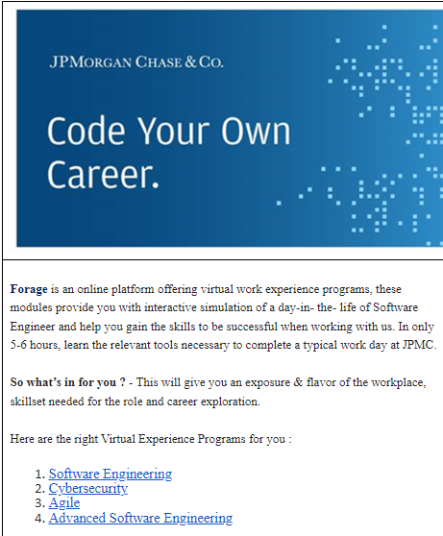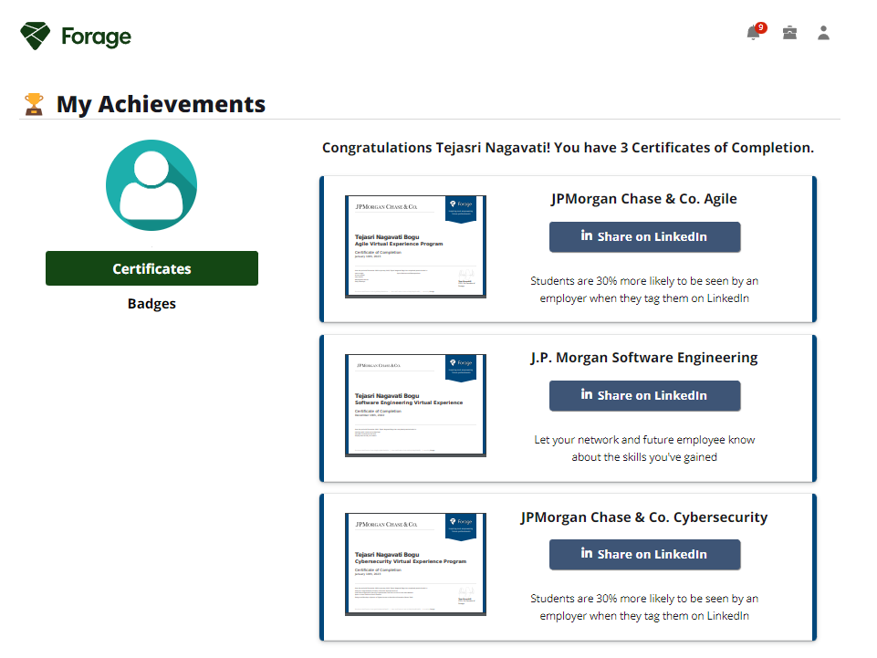
05.12.2022 | Software Engineering (Task 1,2,3)
06.12.2022 | Agile (Task 1,2,3)
07.12.2022 | Agile (Task 4,5,6)
08.12.2022 | Cybersecurity (Task 1,2,3)
09.12.2022 | Cybersecurity (Task 4), Advanced Software Engineering (Task 1)
Implementation | Patent / SCI / Scopus Indexed Journal Paper / Scopus Indexed Conference Paper/ Scopus  Indexed Book Chapter
Work Status | Excellent / Good / Satisfactory / Needs improve
Attendance Status | Regular / Irregular | CAM – Max. 5 Marks per week


Tejasri B N
24.12.23

Signature of the Student with date Name & Signature of the Guide with date

